Literacy support worksheet

5.1 Physical change is a change in shape or appearance

Pages 80–81 and 189–190

Physical changes

1 What is a physical change?

2 Give an example of a physical change and explain why it is a physical change.

3 What happens to the molecules in water when they change state from a liquid to a gas?

4 Give four examples of physical changes in your home:

a

b

c

d

5 Draw a line to match each of the words on the left with its corresponding meaning, on the right.

**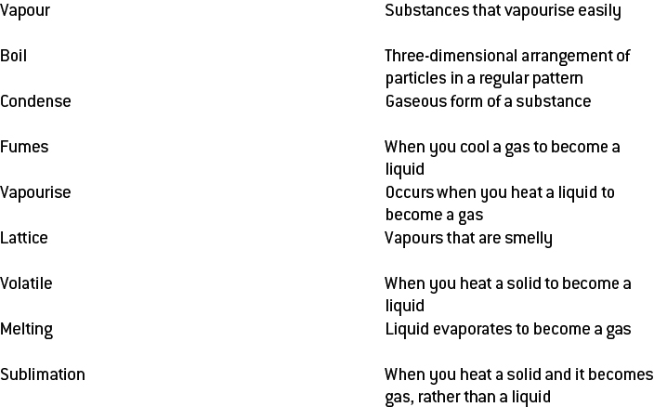**

6 What happens to the molecules in water when they change state from a gas to a liquid?

7 Explain why boiling water is a physical change.

8 Label the following diagram with the correct terminology to illustrate a change in state of water:

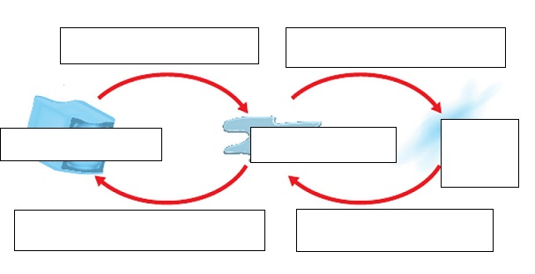

Word detective

9 True or false

Read each of the following statements and indicate whether it is true or false.

a One example of a volatile substance is cooking oil. T or F

b Physical changes are not reversible. T or F

c No new substances are created a physical change. T or F

d Condensation is when a solid is heated and changes state to become a liquid. T or F

e Applying a force to a substance can cause a physical change. T or F

f Water molecules vibrate at a much slower rate when heat energy is added. T or F

g Volatile substances vaporise easily. T or F

h Gases normally change state to become liquid by cooling. T or F

Literacy support worksheet

5.2 Chemical change produces new substances

Pages 82–83 and 190–191

Chemical changes

1 When a chemical change occurs the original substances are rearranged to form:

2 Use the following diagram to explain the difference between a chemical and physical change.

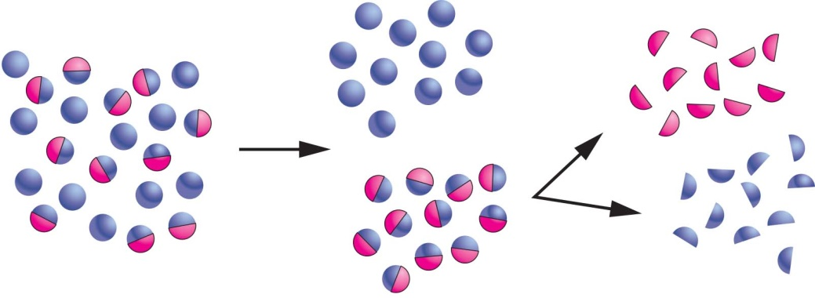

The purple balls represent:

The purple and pink balls represent:

3 What are the four changes that you would look for to know that a chemical change has occurred?

a

b

c

d

4 When chocolate is melted it is a \_\_\_\_\_\_\_\_\_\_\_\_\_\_\_\_\_\_\_\_\_\_\_\_ change because the way it looks changes.

5 When chocolate is burnt it is a \_\_\_\_\_\_\_\_\_\_\_\_\_\_\_\_\_\_\_\_\_\_\_\_ change because it can’t be reversed.

6 When you bake a cake, does a physical or chemical change take place?

7 Are the following pictures examples of chemical or physical changes?

|  |  |  |  |
| --- | --- | --- | --- |
| D:\OS8 worksheets and aw\jpgs ready for worksheets\SW0509_00951.jpg | D:\OS8 worksheets and aw\jpgs ready for worksheets\SW0510_00951.jpg  \_\_\_\_\_ | D:\OS8 worksheets and aw\jpgs ready for worksheets\SW0511_00951.jpg | D:\OS8 worksheets and aw\jpgs ready for worksheets\SW0512_00951.jpg |
| D:\OS8 worksheets and aw\jpgs ready for worksheets\SW0513_00951.jpg | D:\OS8 worksheets and aw\jpgs ready for worksheets\SW0514_00951.jpg | D:\OS8 worksheets and aw\jpgs ready for worksheets\SW0515_00951.jpg | D:\OS8 worksheets and aw\jpgs ready for worksheets\SW0516_00951.jpg |

Word detective

8 Matching meaning

Draw a line to match each picture below with the corresponding sentence on the right. Then, write whether it is a chemical (C) or physical (P) change in the spaces provided.

|  |  |
| --- | --- |
| D:\OS8 worksheets and aw\jpgs ready for worksheets\SW0504_00951-rm.jpg | A tablet dissolves in water generating bubbles. \_\_\_\_\_\_\_\_\_\_\_ |
| D:\OS8 worksheets and aw\jpgs ready for worksheets\SW0505_00951-rm.jpg | A precipitate is a solid that forms from two liquids.  \_\_\_\_\_\_\_\_\_\_\_ |
| **D:\OS8 worksheets and aw\jpgs ready for worksheets\SW0506_00951-rm.jpg** | Sodium, metal and water react to create light and heat.  \_\_\_\_\_\_\_\_\_\_\_ |
| D:\OS8 worksheets and aw\jpgs ready for worksheets\SW0507_00951-rm.jpg | Chocolate is being melted. \_\_\_\_\_\_\_\_\_\_\_ |
| D:\OS8 worksheets and aw\jpgs ready for worksheets\SW0508_00951-r.jpg | An iron nail reacts with water and oxygen to form rust.  \_\_\_\_\_\_\_\_\_\_\_ |

Literacy support worksheet

5.3 Chemical reactions can break bonds and re-form new bonds

Pages 84–85 and 192

Chemical reactions

1 Reactants are chemicals that react when placed together.

What is a chemical product?

2 The diagram below shows a worded chemical reaction.

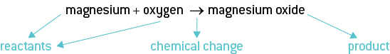

Write a worded chemical equation for the following chemical reactions:

a Oxygen and hydrogen react to form water

b Iron and oxygen will form iron oxide (rusting)

c Water and carbon dioxide react in the leaves of plants to form glucose (a sugar) and oxygen (photosynthesis)

d Petrol, in a car, will burn in the presence of oxygen to form carbon dioxide and water

3 What is a combustion reaction?

4 Write a worded equation for the combustion of magnesium.

5 Fill in the flow diagram by placing the sentences below in the correct order to describe a combustion reaction between magnesium and oxygen:

Magnesium interacts with oxygen in the air.

Start with a magnesium ribbon.

A white powder (magnesium oxide) is formed.

Magnesium ribbon burns.

1 \_\_\_\_\_\_\_\_\_\_\_\_\_\_\_\_\_\_\_\_\_\_\_\_\_\_\_\_\_\_\_\_\_\_\_\_\_\_\_\_\_\_\_\_\_\_\_\_\_\_\_\_\_

2 \_\_\_\_\_\_\_\_\_\_\_\_\_\_\_\_\_\_\_\_\_\_\_\_\_\_\_\_\_\_\_\_\_\_\_\_\_\_\_\_\_\_\_\_\_\_\_\_\_\_\_\_\_

3 \_\_\_\_\_\_\_\_\_\_\_\_\_\_\_\_\_\_\_\_\_\_\_\_\_\_\_\_\_\_\_\_\_\_\_\_\_\_\_\_\_\_\_\_\_\_\_\_\_\_\_\_\_

4 \_\_\_\_\_\_\_\_\_\_\_\_\_\_\_\_\_\_\_\_\_\_\_\_\_\_\_\_\_\_\_\_\_\_\_\_\_\_\_\_\_\_\_\_\_\_\_\_\_\_\_\_\_

6 The products of the combustion of hydrocarbons are carbon dioxide and water. Write worded equations for:

a combustion of ethene

b combustion of octane

Word detective

7 Mumbo jumbo

a Use the marked letters to find the secret word (e.g. olusntoi = solution).

b Unscramble each of the clue words below to find the message.

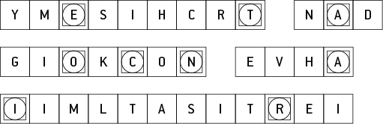

Secret word:

Message:

Literacy support worksheet

5.4 Heat can speed up a reaction

Pages 86–87 and 193–194

The effect of heat on the speed of reactions

1 What factors affect the rate of a reaction?

2 How does particle size effect the rate of a chemical reaction? Finish the sentence.

The smaller the particle size \_\_\_\_\_\_\_\_\_\_\_\_\_\_\_\_\_\_\_\_\_\_\_\_\_\_\_\_\_\_\_\_\_\_\_\_\_\_\_\_\_\_\_\_\_\_\_\_\_\_\_\_\_\_\_\_\_\_\_\_\_.

3 Which of the following diagrams will have a faster rate of reaction, (a) or (b)?

a 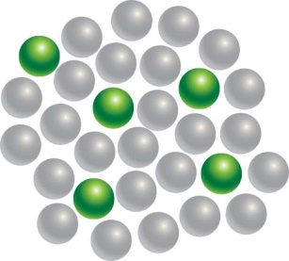 b 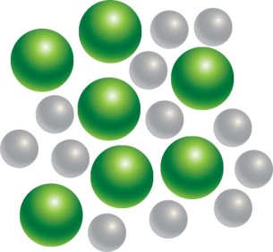

4 What must happen in order for chemicals to react? Finish this sentence.

The more the collisions happen between the particles, the more likely

5 How does temperature increase the rate of a reaction?

6 What type of energy does temperature give to particles?

7 The higher the concentration the more particles it has. How would this affect the amount of collisions?

8 How does the rate of collisions affect the rate of a reaction?

9 Which of the following diagrams will have a faster rate of reaction? Explain your answer.

a 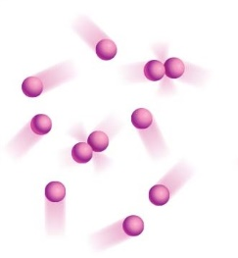 b 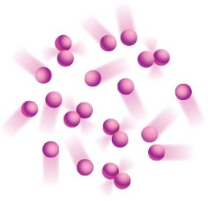

10 What is a catalyst?

11 Why do we need enzymes in our bodies?

Word detective

12 True or false

Read the statement and circle whether it is true or false.

a The concentration of a substance affects the reaction rate. T or F

b The bigger the particles, the faster the reaction. T or F

c The lower the temperature the faster the reaction. T or F

d Collision theory states that the more collisions, the more likely there’s a reaction. T or F

e As coffee cools the kinetic energy in its particles increase. T or F

f Enzymes are catalysts. T or F

g Vitamin C is a catalyst. T or F

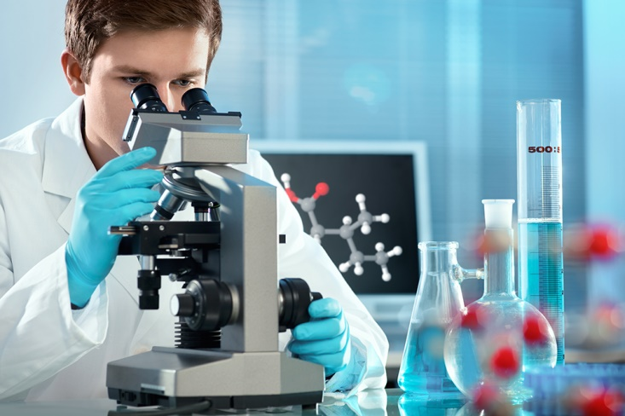Literacy support worksheet

5.5 Many substances exist because of the work of scientists

Pages 88–89 and 195

Chemical substances

1 What do pharmacists study?

2 What field of study do they specialise in?

3 What is a chemist who works in a pharmacy called?

4 Fill in the gaps in the flow diagram on crude oil by using the sentences below.

The low value parts are converted into high value products.

It is carried in pipelines or tankers to refineries.

Oil is pumped from the ground.

Oil is separated into its components.

a

b

c

d

5 What high-value materials is crude oil converted into?

6 What can plastics be used for?

7 What was the first documented case of glue used for and who used it?

8 Which natural glues were used for gluing paper and wood?

9 What was the first dye obtained from?

10 What is an advantage of modern inks over earlier ones?

Word detective

11 Matching meaning

Draw a line to match the type of chemist (on the left) with the job they do (on the right).

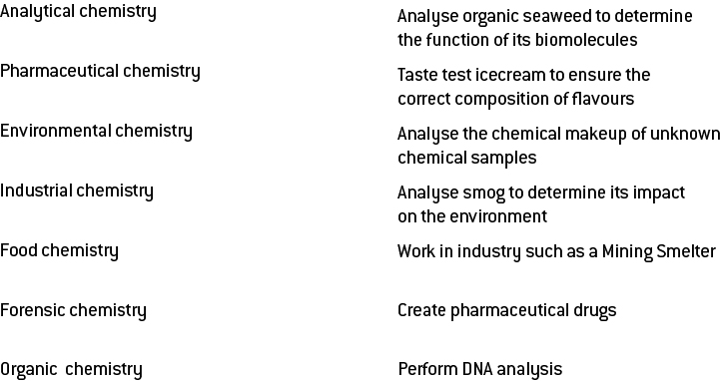

Literacy support worksheet

5.6 Physical and chemical changes are used to recycle household waste

Pages 90–91

Recycling

1 How many groups are plastics classified in to?

2 The steps for the mechanical/physical recycling of plastics, below, are out of order. Place a number next to each sentence to place the steps in the proper order.

|  |  |
| --- | --- |
| Step Number | Description of the process |
|  | Floating off the plastics according to their density |
|  | Cooling the strands and cutting it into small pellets so that it can be reused for new products |
|  | Extruding the plastic by heating it to a melting state and forcing it into long strands |
|  | Cutting the large pieces of plastic using shears or saws |
|  | Separating the contaminants in cyclone (centrifuge) separators |
|  | Shredding the plastic into small flakes |

3 What does the chemical recycling of plastics involve?

4 How can metals be recycled?

5 What is corrosion?

6 What is the difficulty with rusting?

7 Match each of the plastics symbols below with the correct description.

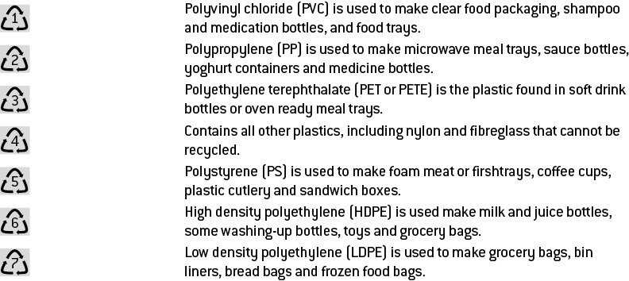

8 Which of the above plastics can be placed in your recycle bin at home? Which cannot?

Word detective

9 Comic strip

Create a comic strip to encourage people to recycle. Use words such as: recycle, landfill, plastics and metals.

|  |  |  |
| --- | --- | --- |
|  |  |  |
|  |  |  |